User Interfaces Design

1. Login Page Design

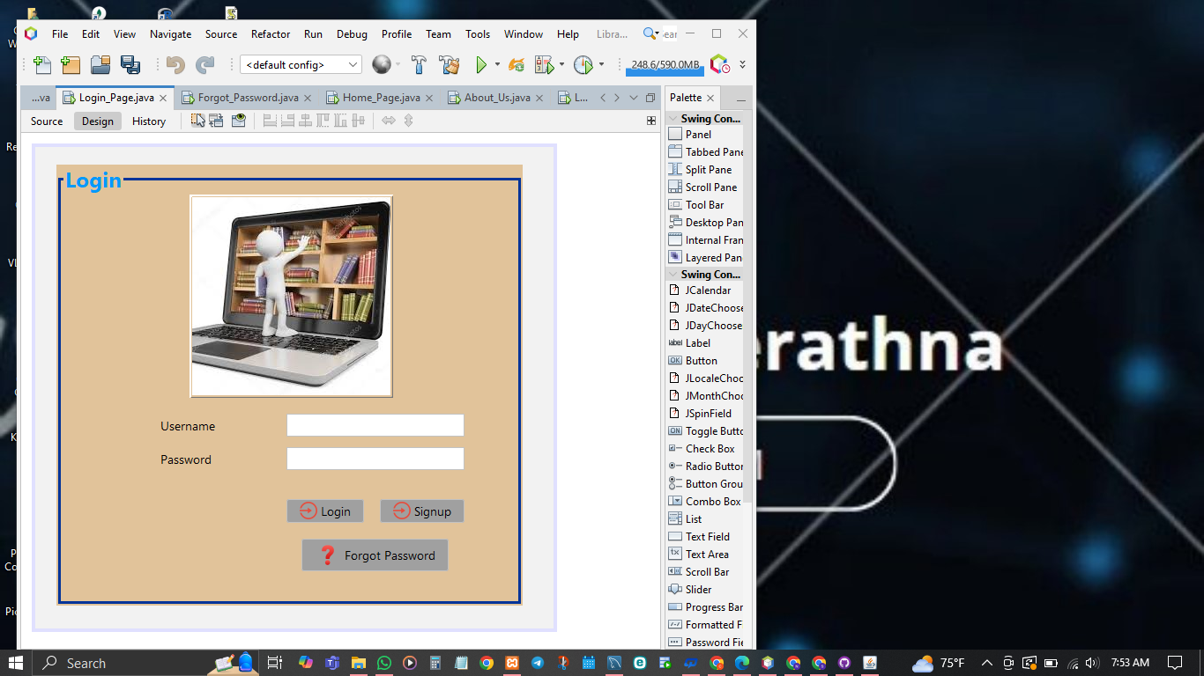

* 1. Forgotten Password page Design

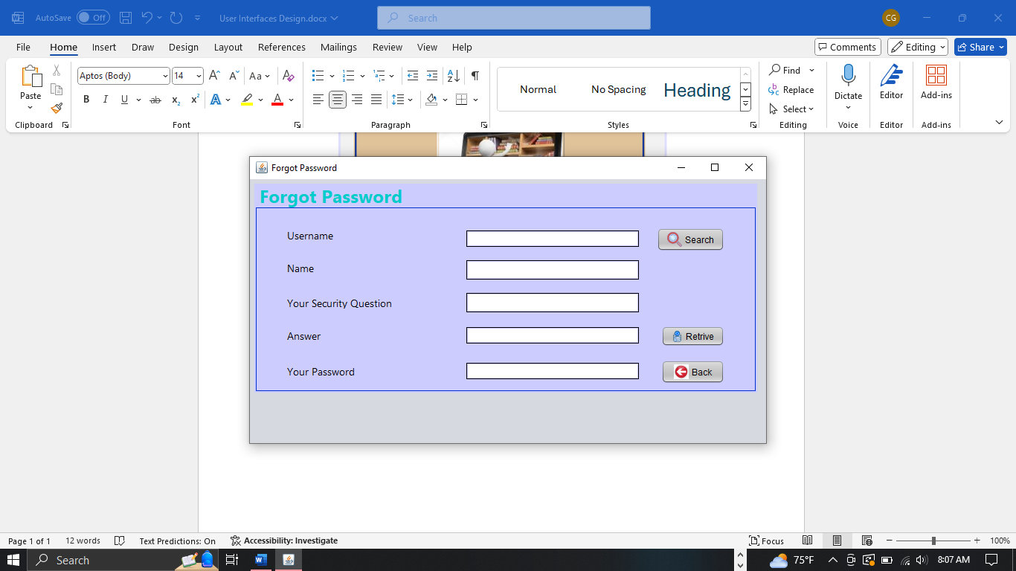

* 1. Signup Page design

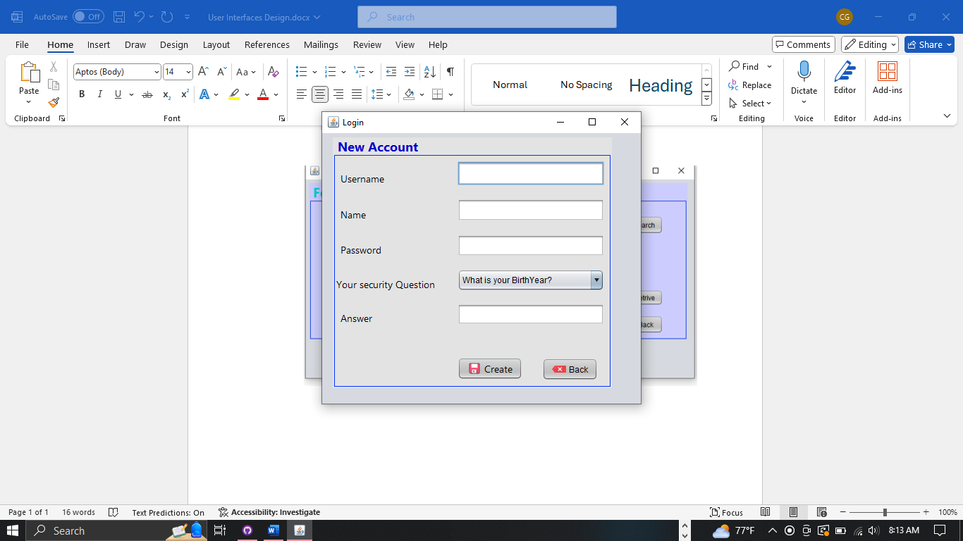

1. Loading page

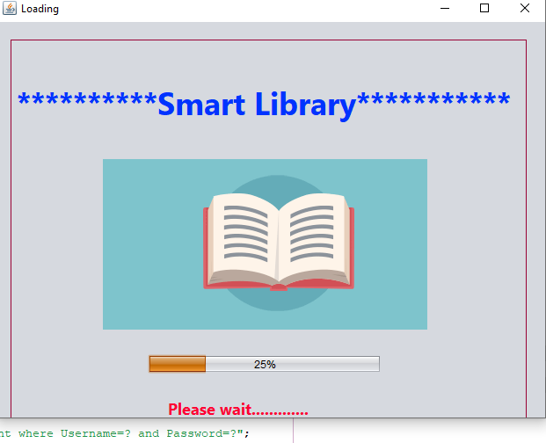

1. Home page

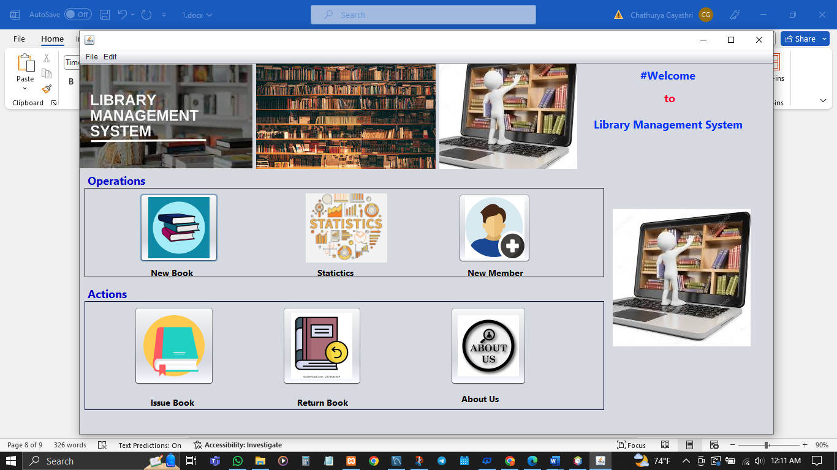

1. New book added

1. New Student

1. Issue book

1. Return book

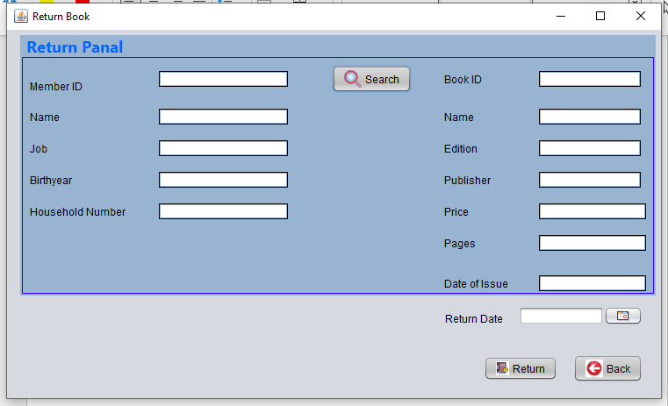

1. Statistics

1. About page

Overview

1. Login/signup/Forgot password _ Chathurya
2. New book/return book/About _ nethmi
3. New Member/issue book _ Sachini